**BANK LOAN QUERY**

**BANK LOAN REPORT| SUMMARY**

**KPI’s**

* **Total Loan Application**

SELECT * FROM financial_loan;

SELECT Count(id) as Total_Loan_Applications FROM financial_loan



1. **MTD Loan Application**

SELECT Count(id) as MTD_Total_Loan_Applications FROM financial_loan

WHERE MONTH(issue_date) = 12 and YEAR(issue_date) = 2021

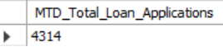

1. **MOM Loan Application**

SELECT Count(id) as PMTD_Total_Loan_Applications FROM financial_loan

WHERE MONTH(issue_date) = 11 and YEAR(issue_date) = 2021



* **Total Funded Amount**

SELECT sum(loan_amount) as Total_Funded_Amount FROM financial_loan;



1. **Total Funded Amount (MTD)**

SELECT sum(loan_amount) as MTD_Total_Funded_Amount FROM financial_loan

where month(issue_date) = 12 and YEAR(issue_date) = 2021;



1. **Total Funded Amount (PMTD)**

SELECT sum(loan_amount) as PMTD_Total_Funded_Amount FROM financial_loan

where month(issue_date) = 11 and YEAR(issue_date) = 2021;

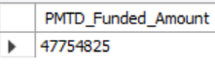

1. **MOM Percentage**

Select

(SUM(CASE WHEN month(issue_date) = 12 THEN loan_amount ELSE 0 END)

-

SUM(CASE WHEN month(issue_date) = 11 THEN loan_amount ELSE 0 END)

)/

SUM(CASE WHEN MONTH(issue_date) = 11 THEN loan_amount ELSE 0 END) * 100 AS MOM_Percentage_Change

from Financial_loan;

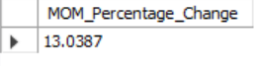

* **Total Amount Received**

SELECT sum(total_payment) as Total_Received_Amount FROM financial_loan;



1. **Total Received Amount (MTD)**

SELECT sum(total_payment) as MTD_Total_Received_Amount FROM financial_loan

where month(issue_date) = 12 and YEAR(issue_date) = 2021;



1. **Total Received Amount (PMTD)**

SELECT sum(total_payment) as PMTD_Total_Received_Amount FROM financial_loan

where month(issue_date) = 11 and YEAR(issue_date) = 2021;



* **Average Interest Rate**

SELECT avg(int_rate)* 100 as Average_Interest_Rate from financial_loan;



1. **Average Interest Rate (MTD)**

SELECT avg(int_rate)* 100 as MTD_Average_Interest_Rate from financial_loan

Where month(issue_date) = 12



1. **Average Interest Rate (PMTD)**

SELECT avg(int_rate)* 100 as PMTD_Average_Interest_Rate from financial_loan

Where month(issue_date) = 11



* **Average DTI**

SELECT avg(Dti)* 100 as Average_DTI from financial_loan;



1. **Average DTI (MTD)**

SELECT avg(dti)* 100 as MTD_Average_DTI from financial_loan

Where month(issue_date) = 12;



1. **Average DTI (PMTD)**

SELECT avg(dti)* 100 as PMTD_Average_DTI from financial_loan

Where month(issue_date) = 11;



**GOOD LOAN ISSUED**

* **Total Good Loan Applications**

SELECT COUNT(Id) as Good_Loan_Application from financial_loan

where loan_status = 'Fully Paid' or loan_status = 'Current';



1. **Good Loan Percentage**

SELECT (Count(Case when loan_status = 'Fully Paid' or loan_status = 'Current' Then id END) * 100)/

Count(id) as Good_Loan_Percentage from financial_loan;



1. **Good Loan Funded Amount**

SELECT sum(loan_amount) as Good_Loan_Funded_Amount from financial_loan

where loan_status = 'Fully Paid' or loan_status = 'Current';



1. **Good Loan Amount Received**

SELECT sum(total_payment) as Good_Loan_Amount_Received from financial_loan

where loan_status = 'Fully Paid' or loan_status = 'Current';



**BAD LOAN ISSUED**

* **Total Bad Loan Applications**

SELECT COUNT(id) as Bad_Loan_Applications from financial_loan

Where loan_status = 'charged off'



1. **Bad Loan Percentage**

SELECT (COUNT(CASE WHEN loan_status = 'Charged Off' THEN id END) * 100.0)/

COUNT(id) AS Bad_Loan_Percentage from Financial_loan



1. **Bad Loan Funded Amount**

SELECT SUM(loan_amount) AS Bad_loan_Funded_Amount from financial_loan

where loan_status = 'Charged Off';



1. **Bad Loan Amount Received**

SELECT SUM(total_payment) AS Bad_loan_Amount_Received from financial_loan

where loan_status = 'Charged Off' ;

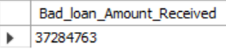

**LOAN STATUS**

SELECT

loan_status,

COUNT(id) as Total_loan_Application,

SUM(loan_amount) as Total_Funded_Amount,

SUM(total_payment) as Total_Amount_Received,

Avg(int_rate)*100 as Interest_Rate,

AVG(dti)*100 as DTI

FROM financial_loan

group by loan_status;

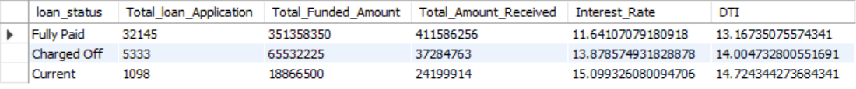

SELECT

loan_status,

Sum(loan_amount) as MTD_Total_Funded_Amount,

Sum(total_payment) as MTD_Total_Amount_Received

FROM financial_loan

Where month(issue_date) = 12

group by loan_status;

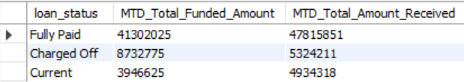

**BANK LOAN REPORT | OVERVIEW**

**MONTH**

SELECT

month(issue_date) as Month_Number,

monthname(Issue_date) as Month_Name,

COUNT(id) as Total_Loan_Applications,

SUM(loan_amount) as Total_Funded_Amount,

SUM(Total_payment) as Total_Amount_Received

from financial_loan

GROUP BY month(issue_date), monthname(Issue_date)

ORDER BY month(issue_date)

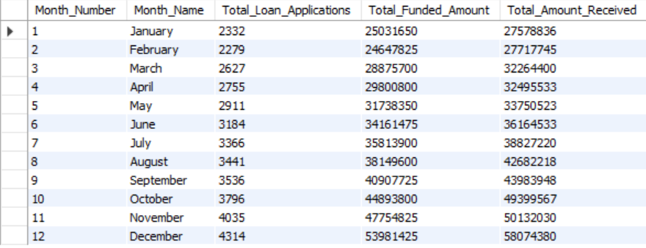

**STATE**

SELECT

ROW_NUMBER() OVER (ORDER BY address_state) AS Serial_Number,

address_state AS State,

COUNT(id) AS Total_Loan_Applications,

SUM(loan_amount) AS Total_Funded_Amount,

SUM(total_payment) AS Total_Amount_Received

FROM financial_loan

GROUP BY address_state

ORDER BY address_state

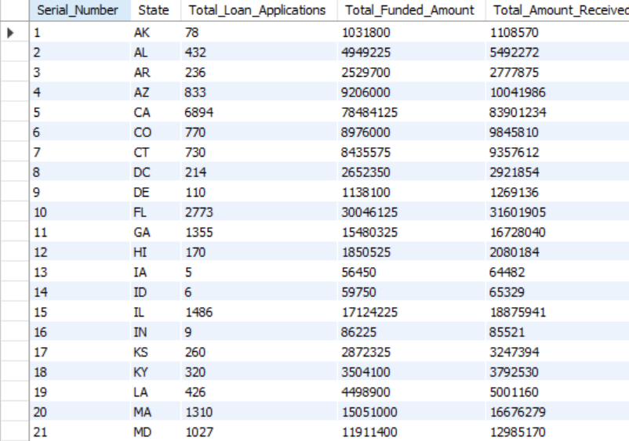

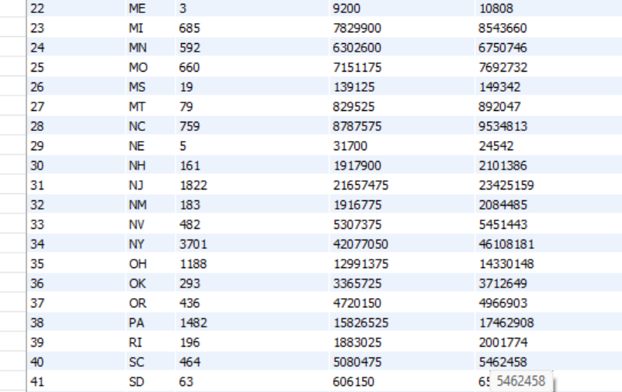

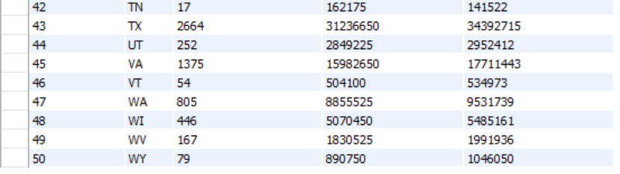

**TERM**

SELECT

row_number()OVER (ORDER BY TERM) AS Serial_No,

term as TERM,

COUNT(id) as Total_Loan_Application,

Sum(loan_amount) as Total_Amount_Funded,

Sum(total_payment) as Total_Amount_Received

from financial_loan

group by term

order by term;

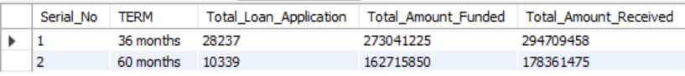

**EMPLOYEE LENGTH**

SELECT

row_number()OVER (ORDER BY emp_length ) AS Serial_No,

emp_length as Employee_Length,

COUNT(id) as Total_Loan_Application,

Sum(loan_amount) as Total_Amount_Funded,

Sum(total_payment) as Total_Amount_Received

from financial_loan

group by emp_length

order by emp_length asc;

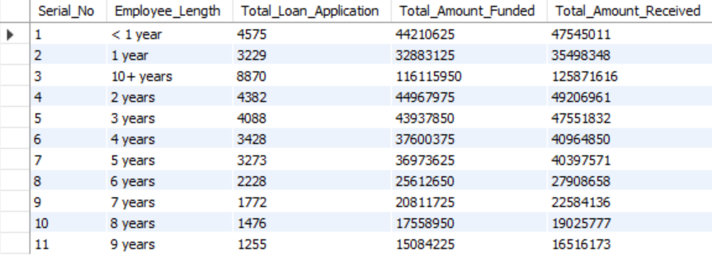

EMPLOYEMENT LENGTH<5

SELECT

ROW_NUMBER() OVER (ORDER BY emp_length ASC) AS Serial_No,

emp_length AS Employee_Length,

COUNT(id) AS Total_Loan_Application,

SUM(loan_amount) AS Total_Amount_Funded,

SUM(total_payment) AS Total_Amount_Received

FROM

financial_loan

where emp_length <5

GROUP BY

emp_length

ORDER BY

emp_length ASC;

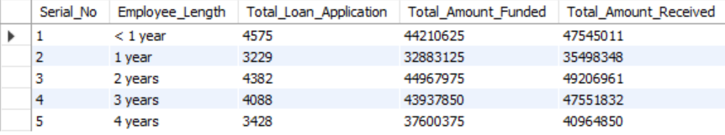

**PURPOSE**

SELECT

ROW_NUMBER() OVER (ORDER BY purpose ASC) AS Serial_No,

purpose AS Purpose,

COUNT(id) AS Total_Loan_Application,

SUM(loan_amount) AS Total_Amount_Funded,

SUM(total_payment) AS Total_Amount_Received

FROM

financial_loan

GROUP BY

purpose

ORDER BY

purpose ASC;

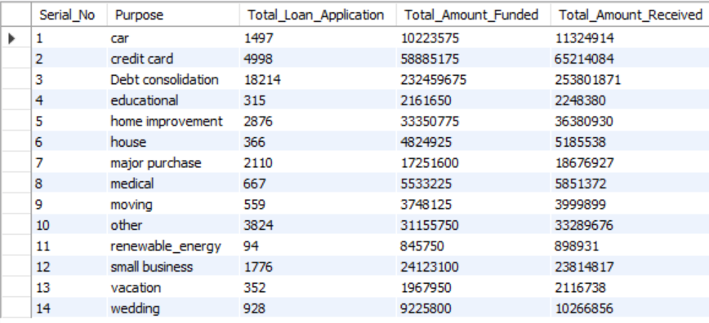

\**Additional\**

SELECT

ROW_NUMBER() OVER (ORDER BY count(id) desc) AS Serial_No,

purpose AS Purpose,

COUNT(id) AS Total_Loan_Application,

SUM(loan_amount) AS Total_Amount_Funded,

SUM(total_payment) AS Total_Amount_Received

FROM

financial_loan

GROUP BY

purpose

ORDER BY

count(id) desc;

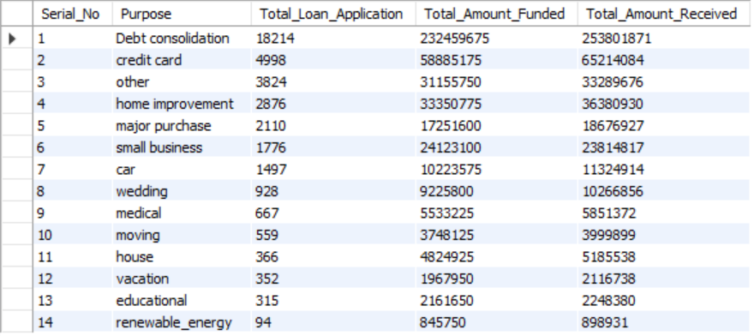

SELECT

ROW_NUMBER() OVER (ORDER BY count(id) desc) AS Serial_No,

purpose AS Purpose,

COUNT(id) AS Total_Loan_Application,

SUM(loan_amount) AS Total_Amount_Funded,

SUM(total_payment) AS Total_Amount_Received

FROM

financial_loan

Where grade = 'B' AND emp_length > 3

GROUP BY

purpose

ORDER BY

count(id) desc;

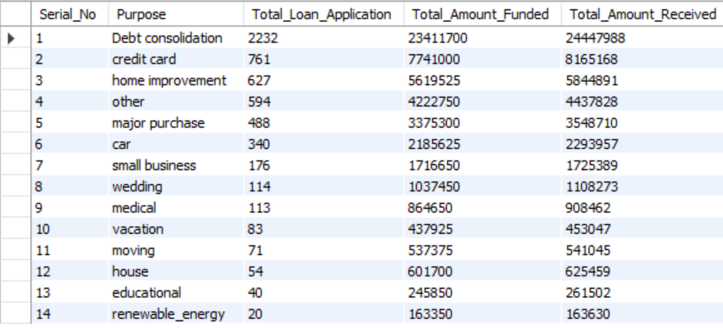

**HOME OWNERSHIP**

SELECT

ROW_NUMBER() OVER (ORDER BY count(id) desc) AS Serial_No,

home_ownership AS Home_Ownership,

COUNT(id) AS Total_Loan_Application,

SUM(loan_amount) AS Total_Amount_Funded,

SUM(total_payment) AS Total_Amount_Received

FROM

financial_loan

GROUP BY

home_ownership

ORDER BY

count(id) desc;

